**Tugas Praktikum Konsep Pemrograman**

**Modul Praktikum 24 - 25 | Pointer 1 & 2**

Nama : Irvan Aditya Kurniawan

Kelas : 1 D4 IT B

NRP : 3124600044

**SOAL :**

**Untuk setiap program dibawah ini,**

* **Gambarkan Ilustrasi alokasi memori dari setiap baris pernyataan yang diproses**
* **Perkirakan hasil eksekusinya**

**Modul Praktikum 24 | Pointer 1**

* **Illustrasi Alokasi :**

|  |  |  |
| --- | --- | --- |
| Variabel | Alamat | Value |
| x | **0060FEF1** | **87** |
| y | **0060FEF2** | **87** |
| *px | **0060FEF3** | **0060FEF1** |

* **Hasil Eksekusi :**

Alamat x = 0060FEF1

Isi px = 0060FEF4

Isi x = 87

Nilai yang ditunjuk oleh px = 87

Nilai y = 87

1. A white background with black text

   Description automatically generated

* **Illustrasi Alokasi :**

|  |  |  |
| --- | --- | --- |
| Variabel | Alamat | Value |
| *pu | **0060FEF1** | **0060FEF3** |
| nu | **0060FEF2** | **0.000** |
| u | **0060FEF3** | **1234.0** |

* **Hasil Eksekusi :**

Alamat dari u = 0060FEF0

Isi pu = 0060FEF0

Isi u = 1234.000000

Nilai yang ditunjuk oleh pu = 0.000000

Nilai nu = 0.000000

1. 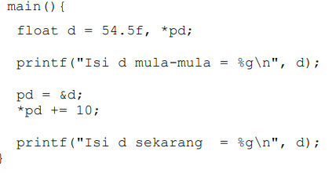

* **Ilustrasi Alokasi :**

|  |  |  |
| --- | --- | --- |
| Variabel | Alamat | Value |
| *pd | **0060FEF2** | **0060FEF1** |
| d | **0060FEF1** | **54.5 64.5** |

* **Hasil Eksekusi :**

Isi d mula-mula = 54.5

Isi d sekarang = 64.5

1. 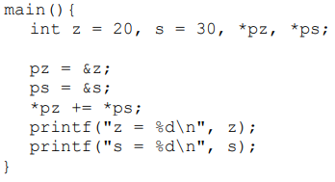

* **Ilustrasi Alokasi :**

|  |  |  |
| --- | --- | --- |
| Variabel | Alamat | Value |
| z | **0060FEF1** | **20 50** |
| s | **0060FEF2** | **30** |
| *pz | **0060FEF3** | **0060FEF1** |
| *ps | **0060FEF4** | **0060FEF2** |

* **Hasil Eksekusi :**

Isi d mula-mula = 54.5

Isi d sekarang = 64.5

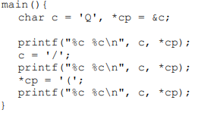



* **Ilustrasi Alokasi :**

|  |  |  |
| --- | --- | --- |
| Variabel | Alamat | Value |
| c | **0060FEF1** | **Q / (** |
| *cp | **0060FEF2** | **0060FEF1** |

* **Hasil Eksekusi :**

Q Q

/ /

( (

1. 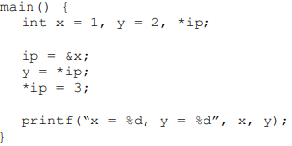

* **Ilustrasi Alokasi :**

|  |  |  |
| --- | --- | --- |
| Variabel | Alamat | Value |
| x | **0060FEF1** | **1 3** |
| y | **0060FEF2** | **2 1** |
| *ip | **0060FEF3** | **0060FEF1** |

* **Hasil Eksekusi :**

x = 3, y = 1

1. 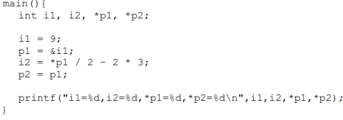

* **Ilustrasi Alokasi :**

|  |  |  |
| --- | --- | --- |
| Variabel | Alamat | Value |
| i1 | **0060FEF1** | **9** |
| i2 | **0060FEF2** | **-2** |
| *p1 | **0060FEF3** | **0060FEF1** |
| *p2 | **0060FEF4** | **0060FEF1** |

* **Hasil Eksekusi :**

i1=9,i2=-2,*p1=9,*p2=9

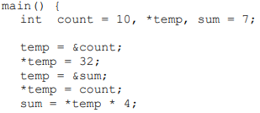





* **Ilustrasi Alokasi :**

|  |  |  |
| --- | --- | --- |
| Variabel | Alamat | Value |
| count | **0060FEF1** | **10 32** |
| sum | **0060FEF2** | **7 32 128** |
| *temp | **0060FEF3** | **0060FEF1 0060FEF2** |

* **Hasil Eksekusi :**

count=32, *temp=128, sum=128

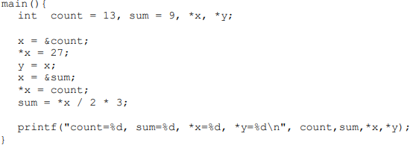



* **Ilustrasi Alokasi :**

|  |  |  |
| --- | --- | --- |
| Variabel | Alamat | Value |
| count | **0060FEF1** | **13 27** |
| sum | **0060FEF2** | **9 27 39** |
| *x | **0060FEF3** | **0060FEF1 0060FEF2** |
| *y | **0060FEF4** | **0060FEF1** |

* **Hasil Eksekusi :**

count=27, sum=39, *x=39, *y=27

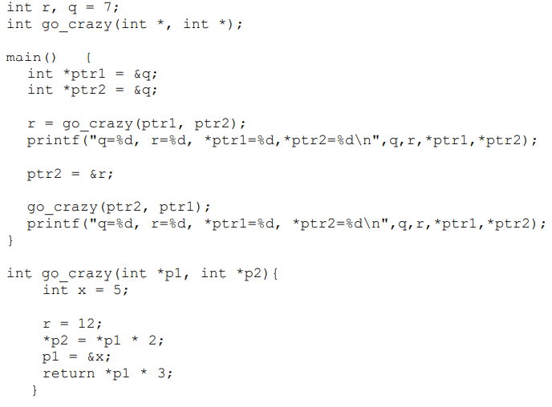



* **Ilustrasi Alokasi :**

|  |  |  |
| --- | --- | --- |
| Variabel | Alamat | Value |
| r | **0060FEF1** | **12 15 12** |
| q | **0060FEF2** | **7 14 24** |
| *ptr1 | **0060FEF3** | **0060FEF2** |
| *ptr2 | **0060FEF4** | **0060FEF2 0060FEF1** |
| *p1 | **0060FEF5** | **0060FEF2 0060FEF7 0060FEF1 0060FEF7** |
| *p2 | **0060FEF6** | **0060FEF2** |
| x | **0060FEF7** | **5** |

* **Hasil Eksekusi :**

count=32, *temp=128, sum=128

**Modul Praktikum 25 | Pointer 2**

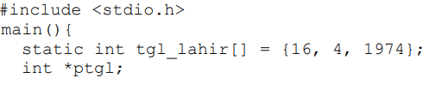



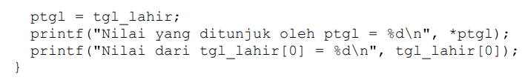

* **Ilustrasi Alokasi :**

|  |  |  |
| --- | --- | --- |
| Variabel | Alamat | Value |
| tgl_lahir[0] | **0060FEE1** | **16** |
| tgl_lahir[1] | **0060FEE2** | **4** |
| tgl_lahir[2] | **0060FEE3** | **1974** |
| *ptgl | **0060FEE4** | **0060FEE1** |

* **Hasil Eksekusi :**

Nilai yang ditunjuk oleh ptgl = 16

Nilai dari tgl_lahir[0] = 16

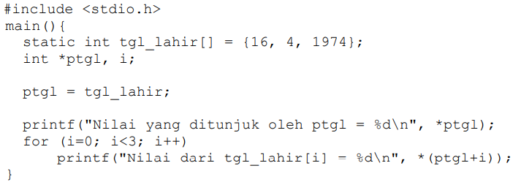



* **Ilustrasi Alokasi :**

|  |  |  |
| --- | --- | --- |
| Variabel | Alamat | Value |
| tgl_lahir[0] | **0060FEE1** | **16** |
| tgl_lahir[1] | **0060FEE2** | **4** |
| tgl_lahir[2] | **0060FEE3** | **1974** |
| *ptgl | **0060FEE4** | **0060FEE1 0060FEE2 0060FEE3** |
| i | **0060FEE5** | **0 1 2** |

* **Hasil Eksekusi :**

Nilai yang ditunjuk oleh ptgl = 16

Nilai dari tgl_lahir[i] = 16

Nilai dari tgl_lahir[i] = 4

Nilai dari tgl_lahir[i] = 1974

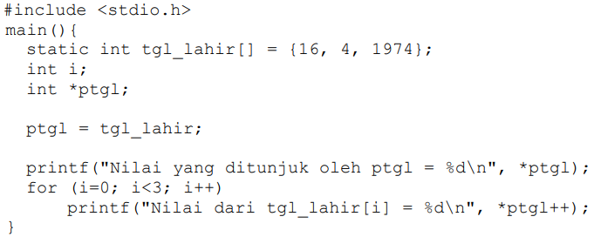



* **Ilustrasi Alokasi :**

|  |  |  |
| --- | --- | --- |
| Variabel | Alamat | Value |
| tgl_lahir[0] | **0060FEE1** | **16** |
| tgl_lahir[1] | **0060FEE2** | **4** |
| tgl_lahir[2] | **0060FEE3** | **1974** |
| i | **0060FEE5** | **0 1 2** |
| *ptgl | **0060FEE4** | **0060FEE1 0060FEE2 0060FEE3** |

* **Hasil Eksekusi :**

Nilai yang ditunjuk oleh ptgl = 16

Nilai dari tgl_lahir[i] = 16

Nilai dari tgl_lahir[i] = 4

Nilai dari tgl_lahir[i] = 1974

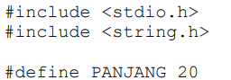



* **Ilustrasi Alokasi :**

|  |  |  |
| --- | --- | --- |
| Variabel | Alamat | Value |
| nama1 [0] | **0060FEE1** | **‘A’ ‘R’** |
| nama1 [1] | **0060FEE2** | **‘H’ ‘I’** |
| nama1 [2] | **0060FEE3** | **‘M’ ‘F’** |
| nama1 [3] | **0060FEE4** | **‘A’ ‘D’** |
| nama1 [4] | **0060FEE5** | **‘D’ ‘A’** |
| nama1 [5] | **0060FEE6** | **‘\0’** |
| nama2 [0] | **0060FEE7** | **‘R’ ‘A’** |
| nama2 [1] | **0060FEE8** | **‘I’ ‘H’** |
| nama2 [2] | **0060FEE9** | **‘F’ ‘M’** |
| nama2 [3] | **0060FEE10** | **‘D’ ‘A’** |
| nama2 [4] | **0060FEE11** | **‘A’ ‘D’** |
| nama2 [5] | **0060FEE12** | **‘\0’** |
| namax [0] | **0060FEE13** | **‘A’** |
| namax [1] | **0060FEE14** | **‘H’** |
| namax [2] | **0060FEE15** | **‘M’** |
| namax [3] | **0060FEE16** | **‘A’** |
| namax [4] | **0060FEE17** | **‘D’** |
| namax [5] | **0060FEE18** | **‘\0’** |

* **Hasil Eksekusi :**

SEMULA :

nama1 --> AHMAD

nama2 --> RIFDA

KINI :

nama1 --> RIFDA

nama2 --> AHMAD

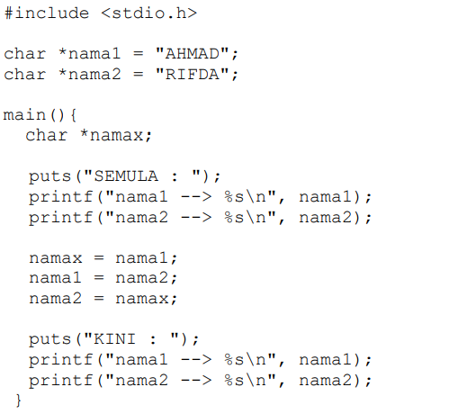



* **Ilustrasi Alokasi :**

|  |  |  |
| --- | --- | --- |
| Variabel | Alamat | Value |
| literal | **0060FEE1** | **'A', 'H', 'M', 'A', 'D', '\0'** |
| literal | **0060FEE2** | **‘R’, ‘I’, ‘F’, ‘D’, ‘A’, ‘\0’** |
| *nama1 | **0060FEE3** | **0060FEE1 0060FEE2** |
| *nama2 | **0060FEE4** | **0060FEE2 0060FEE1** |
| *namax | **0060FEE5** | **0060FEE1** |

* **Hasil Eksekusi :**

SEMULA :

nama1 --> AHMAD

nama2 --> RIFDA

KINI :

nama1 --> RIFDA

nama2 --> AHMAD

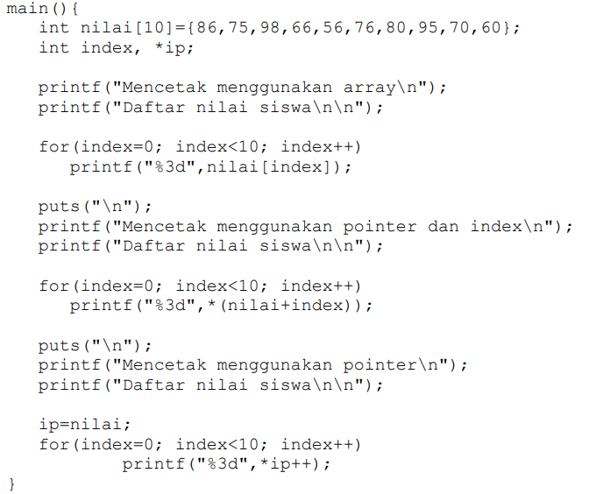



* **Ilustrasi Alokasi :**

|  |  |  |
| --- | --- | --- |
| Variabel | Alamat | Value |
| nilai [0] | **0060FEE1** | **86** |
| nilai [1] | **0060FEE2** | **75** |
| nilai [2] | **0060FEE3** | **98** |
| nilai [3] | **0060FEE4** | **66** |
| nilai [4] | **0060FEE5** | **56** |
| nilai [5] | **0060FEE6** | **76** |
| nilai [6] | **0060FEE7** | **80** |
| nilai [7] | **0060FEE8** | **95** |
| nilai [8] | **0060FEE9** | **70** |
| nilai [9] | **0060FEE10** | **60** |
| Index | **0060FEE11** | **0 1 2 3 4 5 6 7 8 9 0 1 2 3 4 5 6 7 8 9** |
| *ip | **0060FEE12** | **0060FEE1 0060FEE2 0060FEE3 0060FEE4 0060FEE5 0060FEE6 0060FEE7 0060FEE8 0060FEE9 0060FEE10** |

* **Hasil Eksekusi :**

Mencetak menggunakan array

Daftar nilai siswa

86 75 98 66 56 76 80 95 70 60

Mencetak menggunakan pointer dan index

Daftar nilai siswa

86 75 98 66 56 76 80 95 70 60

Mencetak menggunakan pointer

Daftar nilai siswa

86 75 98 66 56 76 80 95 70 60

* **Ilustrasi Alokasi :**

|  |  |  |
| --- | --- | --- |
| Variabel | Alamat | Value |
| tgl_lahir[0] | **0060FEE1** | **16** |
| tgl_lahir[1] | **0060FEE2** | **4** |
| tgl_lahir[2] | **0060FEE3** | **1974** |
| *ptgl | **0060FEE4** | **0060FEE1** |

* **Hasil Eksekusi :**

Nilai yang ditunjuk oleh ptgl = 16

Nilai dari tgl_lahir[0] = 16

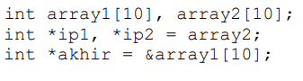



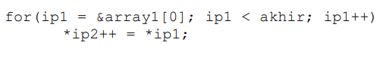

* **Ilustrasi Alokasi :**

|  |  |  |
| --- | --- | --- |
| Variabel | Alamat | Value |
| array1[0] | **006EE1** |  |
| array1[1] | **006EE2** |  |
| array1[2] | **006EE3** |  |
| array1[3] | **006EE4** |  |
| array1[4] | **006EE5** |  |
| array1[5] | **006EE6** |  |
| array1[6] | **006EE7** |  |
| array1[7] | **006EE8** |  |
| array1[8] | **006EE9** |  |
| array1[9] | **006EE10** |  |
| array1[10] | **006EM10** |  |
| array2[0] | **006EE11** |  |
| array2[1] | **006EE12** |  |
| array2[2] | **006EE13** |  |
| array2[3] | **006EE14** |  |
| array2[4] | **006EE15** |  |
| array2[5] | **006EE16** |  |
| array2[6] | **006EE17** |  |
| array2[7] | **006EE18** |  |
| array2[8] | **006EE19** |  |
| array2[9] | **006EE20** |  |
| *akhir | **006EE21** | **006EM10** |
| *ip1 | **006EE22** | **006EE1 006EE2**  **006EE3 006EE4**  **006EE5 006EE6**  **006EE7 006EE8**  **006EE9 006EE10** |
| *ip2 | **006EE23** | **006EE11 006EE12 006EE13 006EE14 006EE15 006EE16 006EE17 006EE18**  **006EE19 006EE20** |

* **Hasil Eksekusi :**

**-**

1. 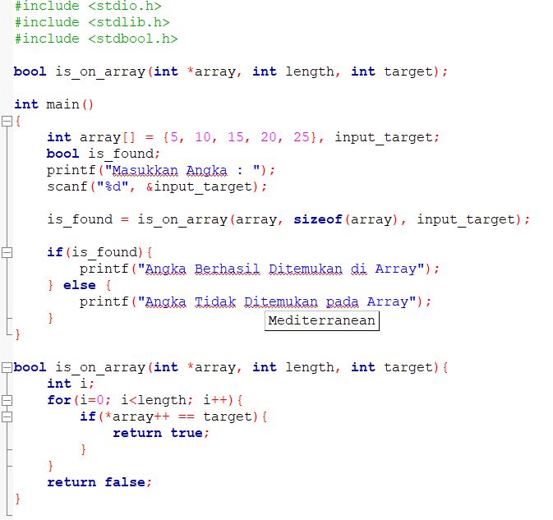

* **Hasil Eksekusi**

* **Analisa :**

Program tersebut bertujuan untuk melakukan pengecekan apakah angka yang diinputkan user ditemukan diarray atau tidak.

* Program tersebut diawali dengan meminta input user.
* Lalu menjalankan fungsi is_on_array() yang memiliki parameter array, panjang array, dan juga input user.
* Lalu pada fungsi is_on_array parameter array akan diterima oleh pointer lalu melakukan looping dengan i sebagai variabel pengendali sampai panjang array dan jika nilai array index ke-i sama dengan input user maka akan mereturn nilai true. Sebaliknya jika tidak ditemukan samapi looping berakhir maka akan mengembalikan nilai false yang ditampung di variabel is_found.
* Setelah itu akan kembali ke fungsi main dan melakukan pengecekkan variabel is_found, jika bernilai true akan memberikan output Angka berhasil ditemukan di Array dan jika bernilai false akan memberikan output Angka tidak ditemukan pada array